1. What information / content do you want displayed? Should I take blurb from evolutio site?

The name. kinematics “health and performance”

For now, what kinematics is about and whos involved. For now just me and I will write some info ASAP

2. Do you want a photo displayed somewhere?

Yes please – I will take a photo of friend with some of my strappings and assessments

3. Any particular colour scheme you would like?

Colour scheme – BLACK / WHITE and a Dark or LIGHT BLUE

4. How many pages?

Pages

1. Introduction / what service we offer
2. Clinician’s / so far me
3. KenesioLogic Tapes / I am the national distributor – courses to come
4. Gallery – what you see is what you get
5. What is the link to your online booking software you mentioned?

I am using cliniko. I don’t know how to work the link??

1. Is there any smarts around how to integrate with this?

Hmm not sure what you are meaning ??

1. 6. I need you to setup your domain name and hosting, so you can give me the FTP details to be able to update your site. Host gator should be fine.

Kinematics.com.au

1. 7. Do you think you will need to update the content of your site often or is it pretty static and simple.

I may need to update as I go?? But for now we can keep it simple please

1. 8. Do you need to have a blog?

Not now, but in future

1. 9. Do you have facebook, twitter, Instagram or any other social media accounts you want to link too.

Eventually bro- just want to get this web sorted first

1. 10. Can you give me a rough sketch of the basic layout you envisage?

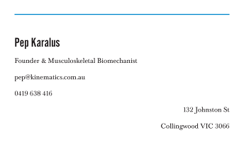

Edit

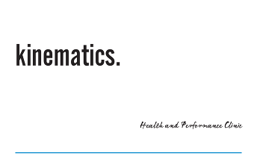

Edit

**Kinematics**

*“health and performance “*

**What we offer.**

- ViMove (running / weight lifting / cycling / pre and post rehabilitation) assessments

- Shockwave therapy

- Lower and upper body musculoskeletal assessments

- Logic taping (Re alignment of the body)

- Prolotherapy

- Chronic and acute pain

- Rehabilitation

- Shoe biomechanics

- Optimisation of musculoskeletal

- INJURY PREVENTIONS IN ALL SPORTS

- IMPROVEMENT OF QUALITY HEALTH and LIFE

Coming soon…

- GP with special interest in sports and men’s health